**GEAR FAULTS**

The ubiquitous of gears in rotating machinery has made the study of vibration a more interesting subject. One study found that 65% of gear box damage is due to faults in the gears (Allianz Versicherungs-AG, 1978). In engineering, they show a considerable number of different forms of damage. The common types of gear damage mainly consist of pitting, scuffi ng, spalling, cracking and wear (Michel & Miller, 1983). One of the major reasons for gear faults is excessive vibration. Vibration can be thought of as a ratio of the forces acting on the gear to its dynamic stiffness. The backlash, the error of the gear transmission, the unbalanced inertia mass, the time varying mesh stiffness of tooth, the friction between

tooth faces and the time varying support stiffness of geared system, change the ratio, ie. vibration which characteristics can reflect symptoms of a lot of faults or defects. The benefit of using vibration analysis for their monitoring and diagnosis has been demonstrated to be successful since the early time because of the ease of measurement. The approaches of gear vibration analysis are mainly subdivided into three categories according to analysis domains. They are time domain, frequency domain and time-frequency domain.

**FREQUENCY DOMAIN APPORCH:**

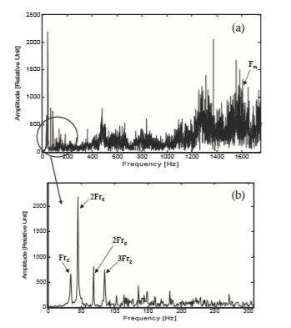The vibration characteristics of any rotating machine are to some extent unique, due to the various transfer characteristics of the machine. In the FFT plot, various large and small peaks are presented corresponding to characteristic frequencies shows the origin of defects; or we can say FFT shows the frequencies in terms of shaft harmonics. For gear problems, special attention must be given to the FFT spectrum’s bearing defect frequencies. The spectra of FFT may produce peaks at identified fault frequencies. These peaks may or may not represent the indicated fault. One must look for harmonics to determine if the identified frequencies were generated from the indicated fault:

• If peak appears at the fundamental fault frequency and another peak appears at two times the fundamental frequency, it is a very strong indication that the fault is real.

• If no peak appears at the fundamental fault frequency, but peaks are present at two, three and maybe four times the fundamental fault frequency, then this also represents a strong indication that the indicated fault is valid.

Figure(a) A typical FFT spectrum of defected gear vibration signal. Figure(b) Zoom view of a typical FFT spectrum of defected gear vibration signal.

The frequency domain spectrum of the vibration signal reveals frequency characteristics of vibrations if the frequencies of the impulse occurrence are close to one of the gear characteristic frequencies, such as gear frequency, pinion frequency, gear mesh frequency, as shown in equations. Then it may indicate a defect related fault in the gearbox.

The gear frequency is given by = Speed of gear /60 [Hz]

The tooth mesh frequency GMFF is given by: gear frequency *Ng [Hz]

Ng is the number of teeth on the gear